1.create and configure a VM for windows and linux

Created new RG : RG1 Region: West US

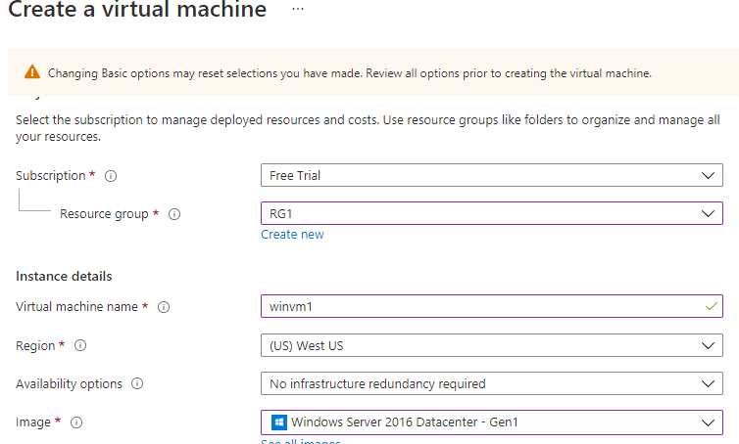

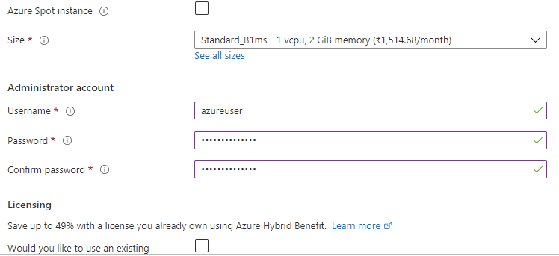

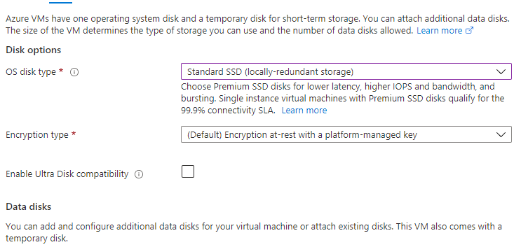

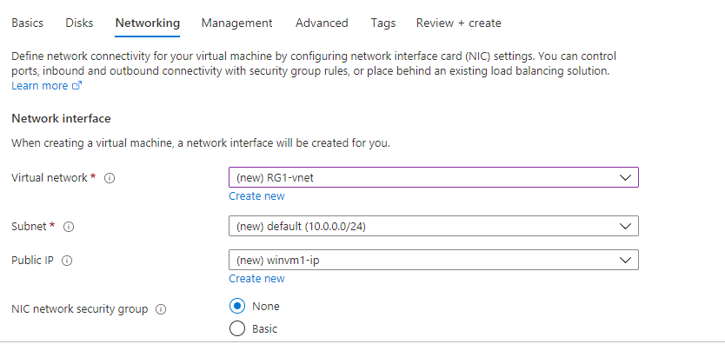

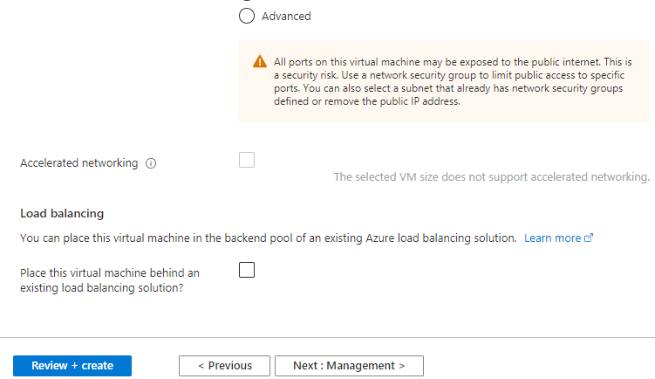

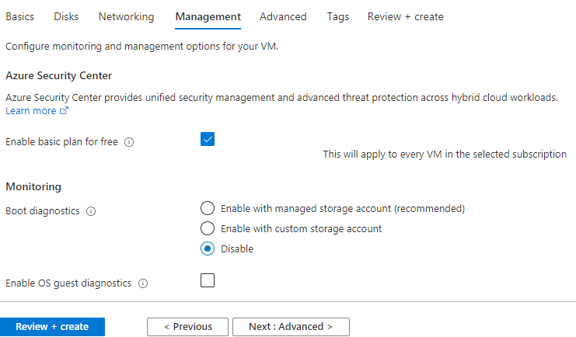

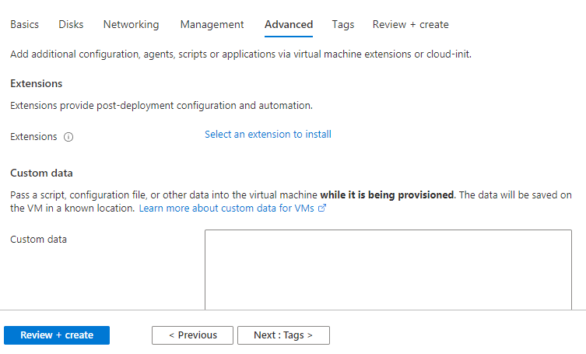

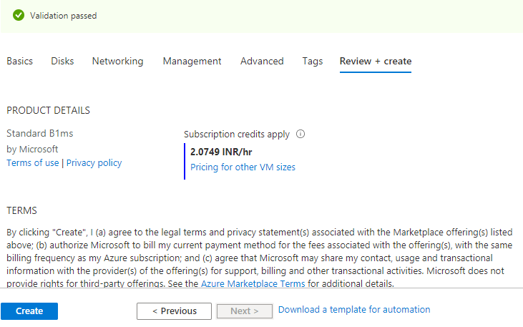

Linux VM:

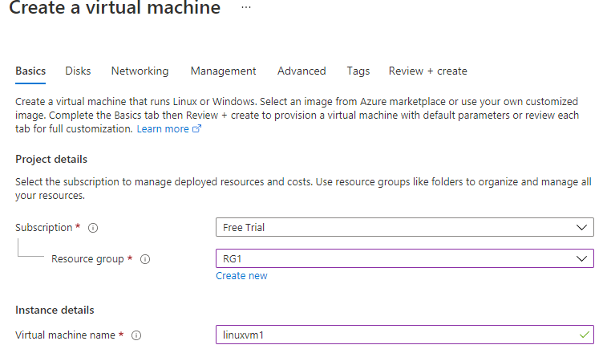

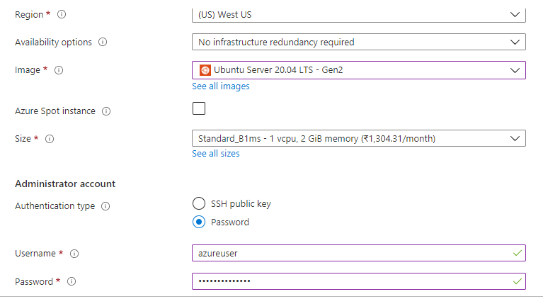

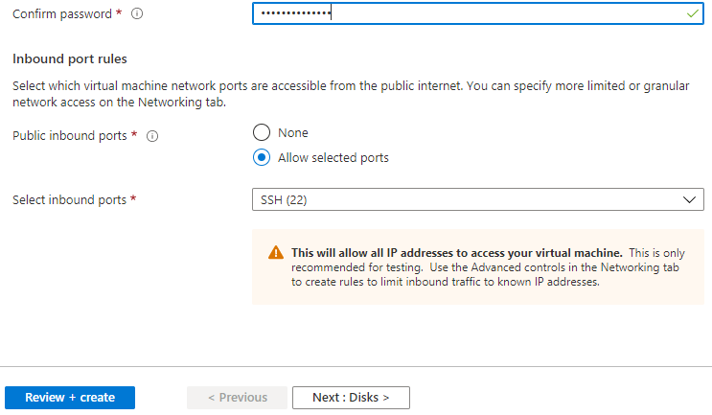

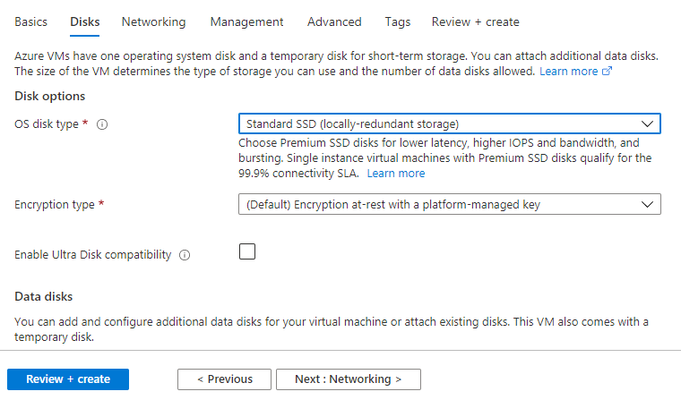

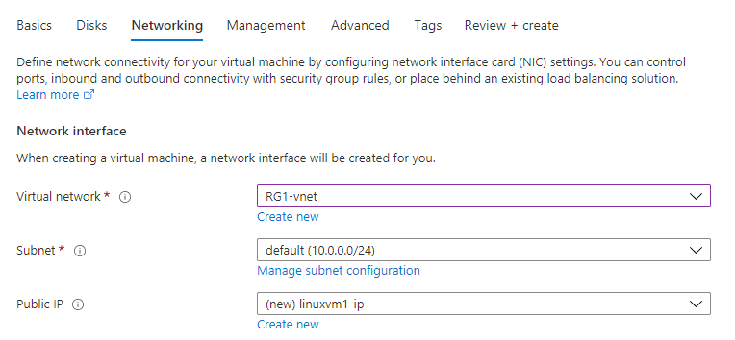

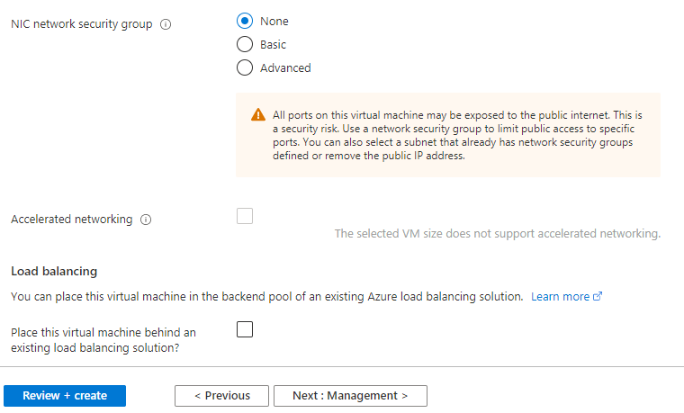

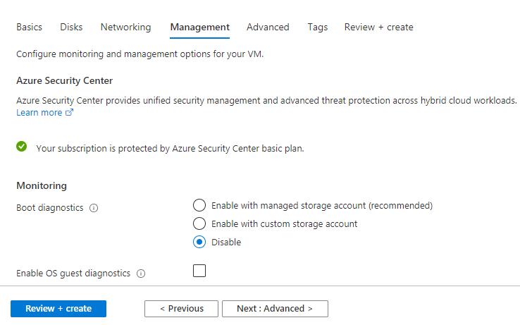

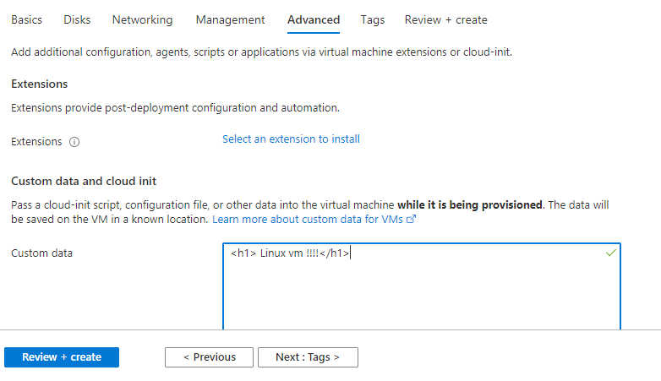

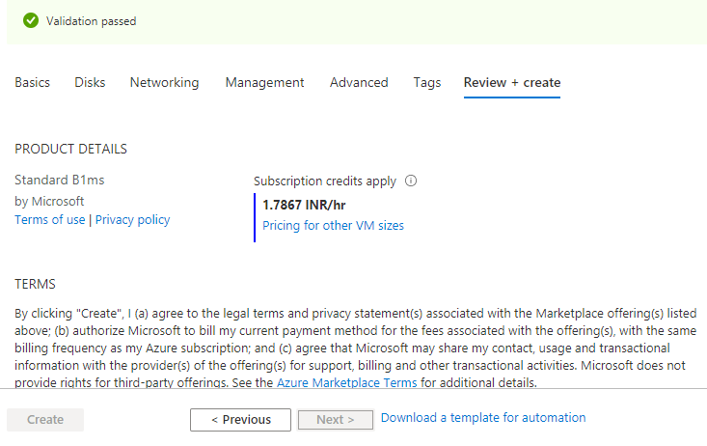

OUTPUT:

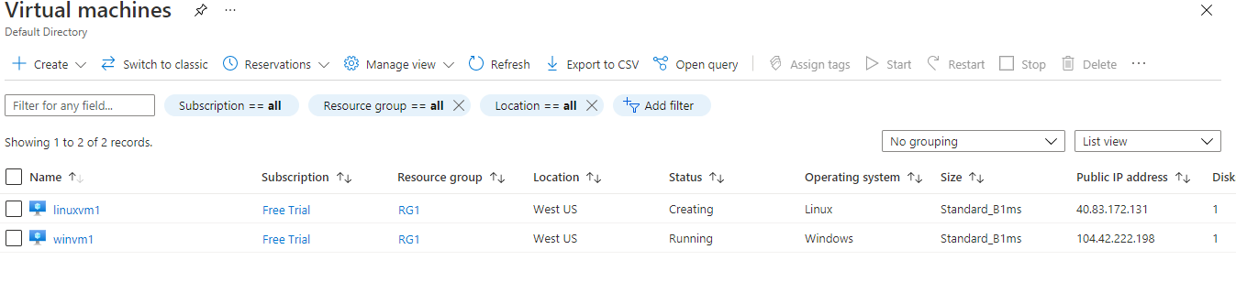

2. create storage account

RG: RG1 location: west us

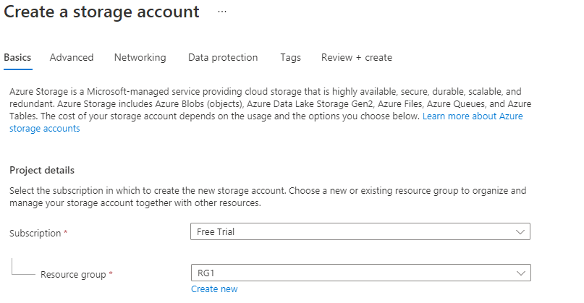

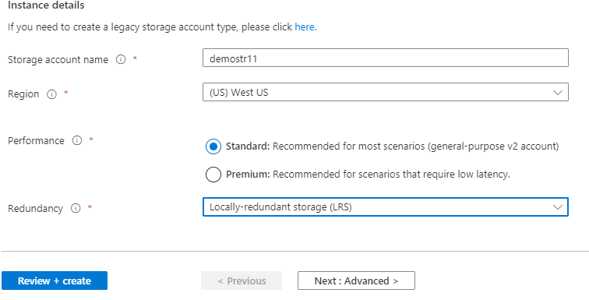

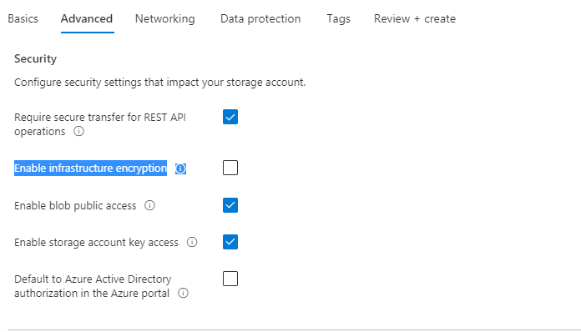

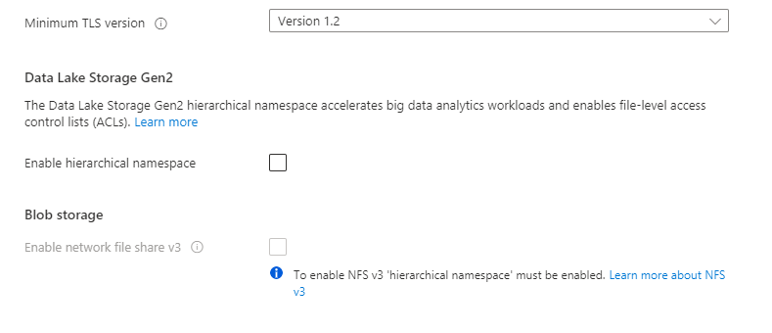

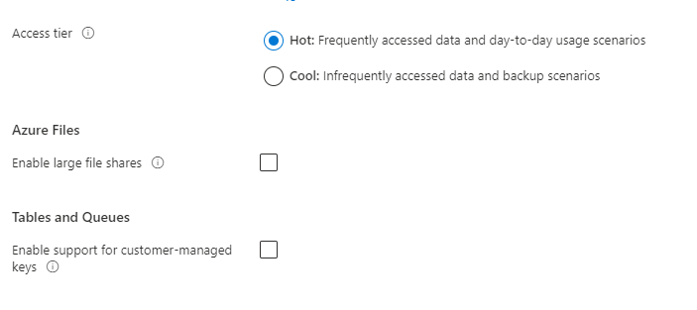

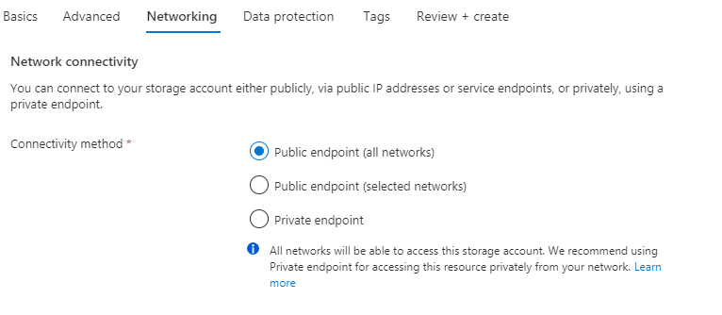

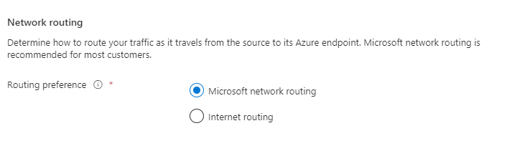

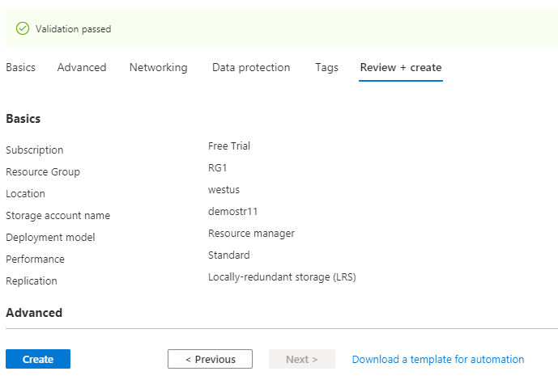

3. Objective- create Azure file share

Select storage account demostr11



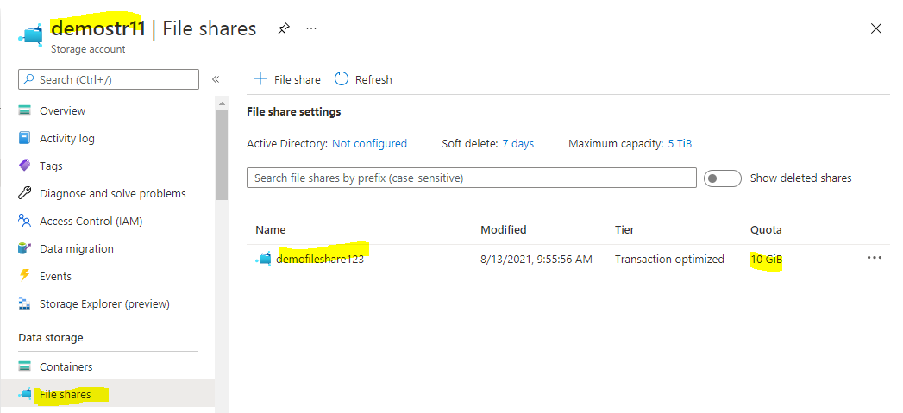

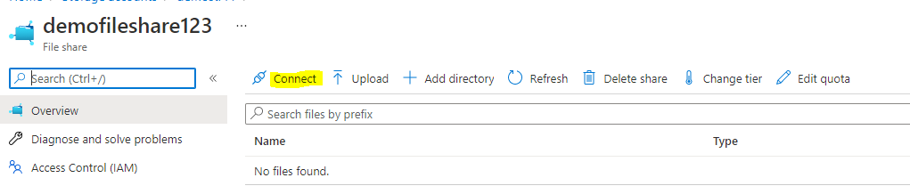

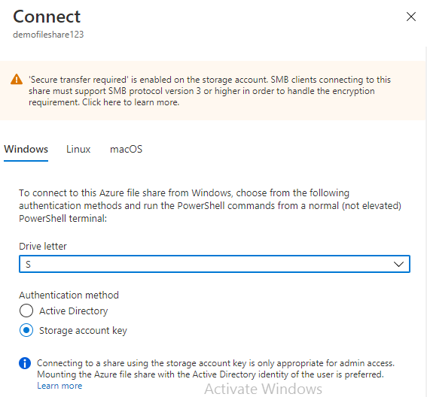

$connectTestResult = Test-NetConnection -ComputerName demostr11.file.core.windows.net -Port 445

if ($connectTestResult.TcpTestSucceeded) {

# Save the password so the drive will persist on reboot

cmd.exe /C "cmdkey /add:`"demostr11.file.core.windows.net`" /user:`"localhost\demostr11`" /pass:`"Bx/J0+UHBrbj3N+ZqrE/hGlwy6g9Fbc4kSXnAaoq3PmZ4EUc76I0J4ScbMEVxe7ySUQbQpp36TySipi3GbJnTA==`""

# Mount the drive

New-PSDrive -Name S -PSProvider FileSystem -Root "\\demostr11.file.core.windows.net\demofileshare123" -Persist

} else {

Write-Error -Message "Unable to reach the Azure storage account via port 445. Check to make sure your organization or ISP is not blocking port 445, or use Azure P2S VPN, Azure S2S VPN, or Express Route to tunnel SMB traffic over a different port."

}

Now connect windows VM and install storage explorer and connect azure account

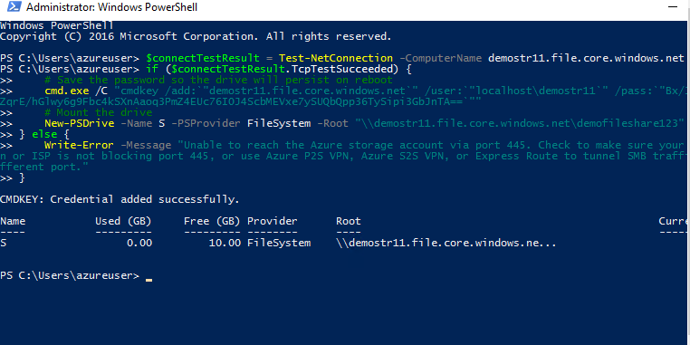

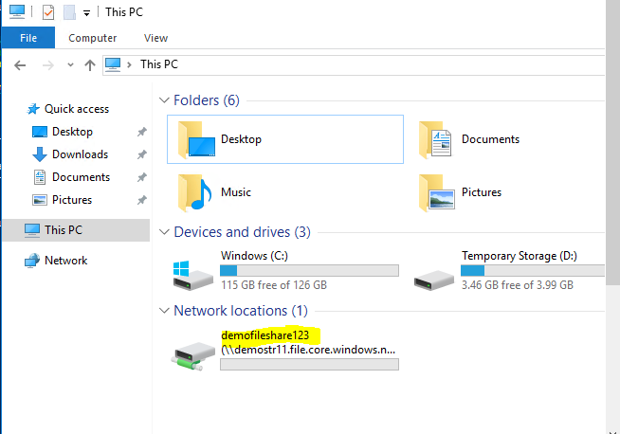

4. create and configure virtual network

Rg: rg1 location: west us

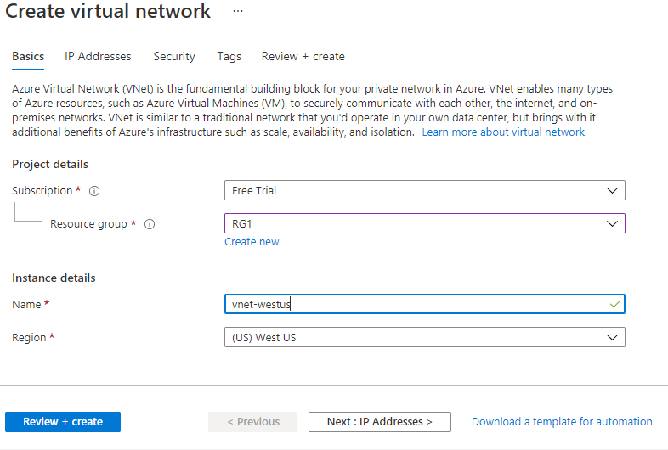

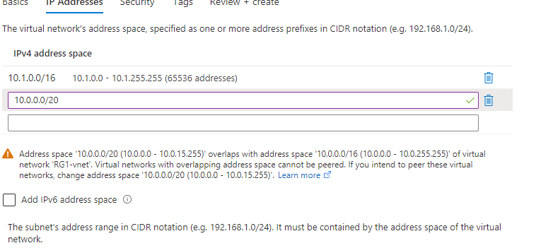

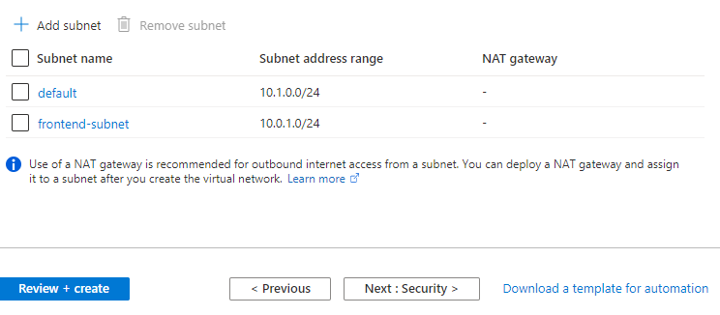

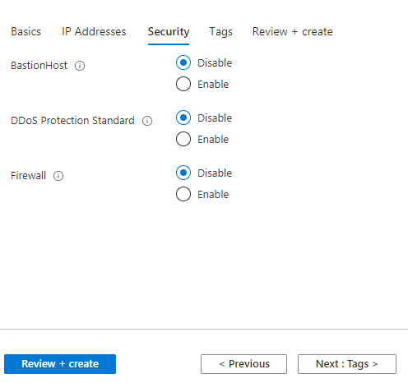

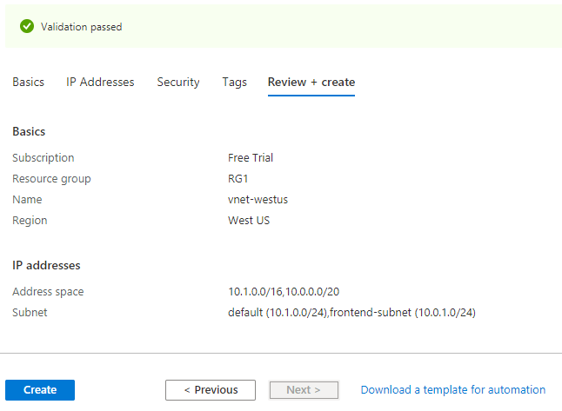



5. create and configure a subnet

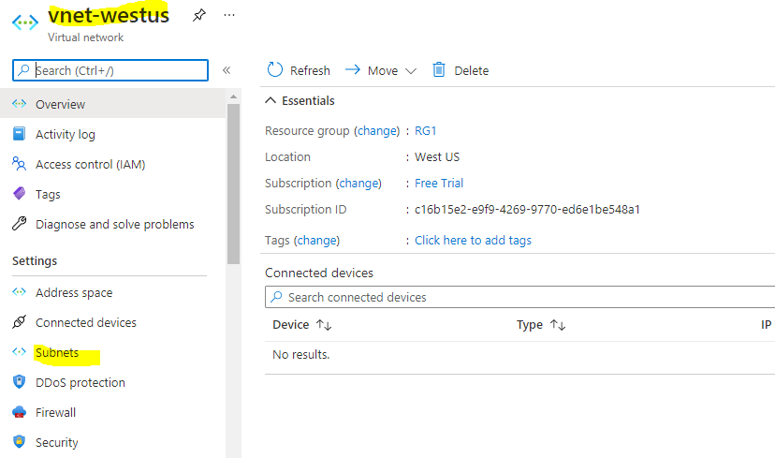

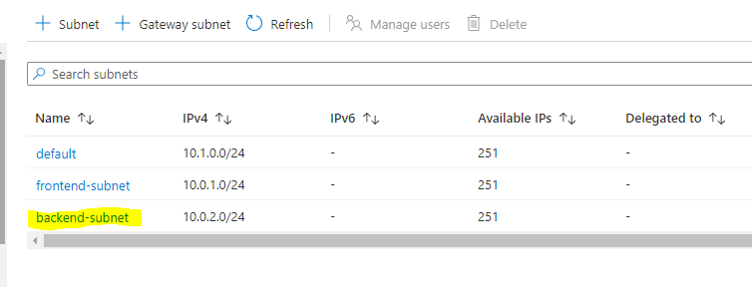

6. create and configure public IP address

